LAB 2: CRASHLOOP BACKOFF
What is CrashLoopBackOff?
CrashLoopBackOff means a container starts, crashes, Kubernetes restarts it, and this keeps happening repeatedly.
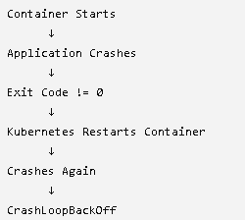
Real-Time Example (Netflix Payment Service)
Suppose a payment application needs a database connection.
Application starts:
Starting Payment Service...
Connecting to MySQL...
But database hostname is wrong:
mysql-prod-service
Application cannot connect:
Database Connection Failed
Application exits:
exit 1
Kubernetes sees the container stopped and restarts it.
Again:
Start → Fail → Restart
Start → Fail → Restart
Start → Fail → Restart
Finally:
STATUS = CrashLoopBackOff
Why "BackOff"?
Kubernetes doesn't restart immediately forever.
It waits longer after each failure:
1st Crash → Restart after few seconds
2nd Crash → Wait longer
3rd Crash → Wait even longer
This waiting period is called BackOff.
Important Interview Question
Difference Between Error and CrashLoopBackOff
Error:
Database Connection Failed
This is the actual application issue.
CrashLoopBackOff:
Container keeps crashing and restarting.
This is Kubernetes telling you there is a repeated crash.
One-Line Definition
CrashLoopBackOff is a Kubernetes pod state where the container repeatedly crashes after starting, and Kubernetes keeps restarting it with increasing delays between attempts.

Lets now perform the lab:

CrashLoopBackOff Lab (Netflix Payment Service Real-Time Example)
Real-Time Scenario
Imagine Netflix has a payment microservice.
Developer accidentally changes:
DB_HOST=mysql-service
TO
DB_HOST=mysql-prod-service
But mysql-prod-service does not exist.
Application starts:
Application Started
Connecting to Database...
Database Connection Failed
Exit 1
Container exits.
Kubernetes restarts it.
Again fails.
Again restarts.
Eventually:
CrashLoopBackOff
Step 1: Create a Broken Deployment
cat <<EOF | kubectl apply -f -
apiVersion: apps/v1
kind: Deployment
metadata:
name: payment-service
spec:
replicas: 1
selector:
matchLabels:
app: payment
template:
metadata:
labels:
app: payment
spec:
containers:
- name: payment
image: busybox
command:
- sh
- -c
- |
echo "Connecting to database..."
exit 1
EOF

Check:
kubectl get pods -w
Output:
payment-service-xxx 0/1 CrashLoopBackOff

Step 2: Troubleshoot Like Production Engineer
Check Pod Status
kubectl get pods
Output:
NAME READY STATUS
payment-service-xxxx 0/1 CrashLoopBackOff
Describe Pod
kubectl describe pod <pod-name>
Look at Events:
Back-off restarting failed container
Check Logs
Most important command:
kubectl logs <pod-name>
Output:
Connecting to database...
Pod exits immediately.
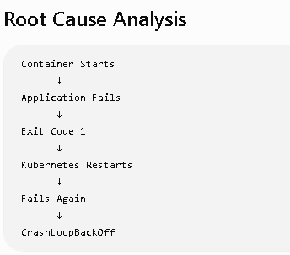

Fix
Edit Deployment:
kubectl edit deployment payment-service
Replace:
exit 1
with:
sleep 3600
Or:
while true; do
echo "Application Running"
sleep 30
done
Verify:
kubectl rollout restart deployment payment-service
Check:
kubectl get pods
Output:
payment-service-xxx 1/1 Running

Real Production Causes of CrashLoopBackOff
1. Wrong Database Endpoint
DB_HOST=mysql-prod
Database not reachable.

2. Missing Secret
env:
- name: DB_PASSWORD
valueFrom:
secretKeyRef:
name: db-secret
Secret deleted accidentally.

3. Wrong ConfigMap
APP_PORT=8080
Application expects:
APP_PORT=9090
Application crashes during startup.

4. Java Out Of Memory
java.lang.OutOfMemoryError
Container exits repeatedly.

5. Invalid Application Code
Developer pushes bad build.
NullPointerException
Application crashes on startup.

